

City of Bastrop REQUEST FOR PROPOSAL
BID REFERENCE NUMBER: WWW-2025-04

PROJECT TITLE: WATER/WASTEWATER MOWING & LANDSCAPING SERVICES

BID DEADLINE AND OPENING: September 26, 2025 AT 2:00 P.M.

Bidders must submit complete original Bid Packet
No bids submitted after the above deadline will be accepted.

Contact: JAMES WILSON, WATER & WASTEWATER SUPERINTENDENT at JWILSON@CITYOFBASTROP.ORG.



The City of Bastrop is accepting Competitive Sealed Bids for an Agreement for MAINTENANCE, MOWING & LANDSCAPING SERVICES for a period of one (1) year, with three (3) one (1) year extensions, if both parties agree.

BIDDERS MUST SUBMIT THE COMPLETE ORIGINAL BID PACKET. They will be received by
the City Secretary’s office, located at 1311 Chestnut Street, Bastrop, Texas 78602, UNTIL 2:00 P.M. LOCAL TIME, SEPTEMBER 26, 2025. Thereafter, bids will be publicly opened and read aloud for products/services listed above.

Specifications, bid proposal forms and instructions to bidders are posted on www.cityofbastrop.org for vendors to download. The City is not responsible for any vendor’s costs associated in the preparation of the bid. Also, should a vendor bid an alternate, any test costs to prove equality of product will be at the expense of the vendor, not the City of Bastrop.

Any bids received after the time and date listed above, regardless of the mode of delivery, shall be returned unopened.

Any technical questions should be directed to James Wilson, Water & Wastewater Superintendent at jwilson@cityofbastrop.org.

The City of Bastrop reserves the right to reject any or all bids, in whole or part, to waive any informality in any bid, and to accept the bid which, in its discretion, in the best interest of the City of Bastrop.

BIDDERS-READ VERY IMPORTANT

RESPONSIVE TO SPECIFICATIONS” AND MAY NOT BE CONSIDERED FOR FURTHER EVALUATION. ***
*** VENDOR IS TO SUBMIT THE COMPLETE ORIGINAL BID PACKET TO FACILITATE EVALUATION. IF THE COMPLETE ORIGINAL BID PACKET IS NOT SUBMITTED, YOUR BID MAY BE CONSIDERED AS “NON-

BID PACKET
You must submit every document specified in the bid packet.

PERIOD OF CONTRACT:

GENERAL CONDITIONS:

ORDERING:

Contract will be for a period of one (1) year with the initial contract requiring approval by City Council. Contract may be renewed for three (3) one (1) year extensions upon the written agreement of the parties.

This contract shall be for the primary purpose of providing Mowing and Landscaping services.

Material and/or services furnished under this contract shall be ordered by the issuance of a purchase order by the City of Bastrop.

CANCELLATION OF CONTRACT: The City of Bastrop may terminate this contract with a thirty (30) day
INVOICING AND INSURANCE: | written notice.  Invoices and insurance will be sent to the following: City of Bastrop  ATTN: Water/Wastewater Dept.  1311 Chestnut Street  Bastrop, TX 78602
NON-APPROPRIATION FUNDS: | Non-appropriation of funds for services or purchases by the City of Bastrop shall render this contract null and void.
INSURANCE REQUIREMENTS: | Please read the City of Bastrop insurance requirements. Make sure  you can meet them as listed. If you are awarded the bid, you must be able to obtain the necessary insurance within five (5) days.

QUESTIONS: | Any technical questions regarding these specifications or contract  may be directed to James Wilson, Water & Wastewater Superintendent, at jwilson@cityofbastrop.org on Monday through Friday, between the hours of 7:00 a.m. and 3:30 p.m.

INTENT
It is the intent of these specifications to describe the Mowing and Landscaping services for which the City of Bastrop is requesting bids, in order to establish a contract. Contract will be for a period of one (1) year with the initial contract requiring approval by City Council. Contract may be renewed for three (3) one (1) year extensions upon the written agreement of the parties.

- Successful bidder will be awarded a contract for one (1) year from date of Council approval.

- The contract may be terminated by either party upon written thirty (30) days’ notice prior to cancellation. Continuing non-performance of the vendor in terms of following specifications shall be a basis for termination by the City of this contract.

- The City may award orders to secondary vendors in cases where contract cannot be fulfilled by the primary source receiving the award.

MINIMUM SPECIFICATIONS

The City of Bastrop is requesting bids for Mowing and Landscaping. Bids should include the complete cost for services as described in the Scope of Work. All services shall meet the City of Bastrop specifications per Exhibit A.

A list of locations to be serviced, as well as an aerial map, are provided in Exhibit A.
PERFORMANCE AND PAYMENT BONDS: The Government Code mandates that a city contracting for public work in excess of $50,000 shall require its contractor to execute a payment bond solely for the protection of beneficiaries who supply materials or labor to the public works project and have a direct contractual relationship with the contractor.

The Government Code also mandates that a city contracting for public work in excess of
$100,000 shall require its contractor to execute a performance bond solely for the protection of the city. The performance bond protects the city in the event of a contractor default and/or termination. Both the payment and performance bonds must be written for the total contract value and should be executed by a corporate surety in accordance with the Insurance Code prior to commencement of the work.

TERMINATION CLAUSE: Either party may terminate this agreement by providing the other party thirty
(30) days prior written notice to terminate.

SIGNATURE AND COMPANY INFORMATION
Company Name
Mailing Address
Physical Address
City, State, Zip Code
Phone Number
Fax Number
Email Address
Tax ID Number
Signature of Authorized Agent
Printed Name of Authorized Agent
Title
Date

SUBMITTAL OF BID:
REMEMBER, EACH VENDOR IS TO SUBMIT THE COMPLETE ORIGINAL BID PACKET TO FACILITATE EVALUATION. IF THE COMPLETE ORIGINAL BID PACKET IS NOT SUBMITTED, YOUR BID MAY BE CONSIDERED AS “NON-RESPONSIVE TO SPECIFICATIONS” AND MAY NOT BE CONSIDERED FOR FURTHER EVALUATION.
Be sure envelope is completely and properly identified and sealed, showing the bid number, bid due date and bid name in the lower left-hand corner. Failure to comply may result in a late bid delivery.
LATE BIDS WILL NOT BE ACCEPTED!

Mailing Address or Hand Delivery or Delivery Service City of Bastrop, City Hall
City Secretary’s Office 1311 Chestnut Street
Bastrop, Texas 78602

PROPERLY IDENTIFIED ENVELOPE (10” x 13” Clasp or Sealed Envelope)
(RETURN ADDRESS) (STAMP)

BID NUMBER: www-2025-04
CITY OF BASTROP CITY SECRETARY’S OFFICE
1311 CHESTNUT STREET
BASTROP, TEXAS 78602

BID DUE DATE: SEPTEMBER 26, 2025 AT 2:00 P.M.
BID NAME: WATER & WASTEWATER MOWING & LANDSCAPING SERVICES

SUPPLEMENTAL INFORMATION AFFIDAVIT OF NO PROHIBITED INTEREST

I, the undersigned declare and affirm that no person or officer in this sole proprietorship, partnership, corporation, or board has, or will have during the term of this contract, a prohibited interest as that term is defined in Article 1.15, Divisions 1,2, and 3. Code of Ethics, or Conflict of Interest, of the City of Bastrop City Charter and Articles, of the Bastrop Code of Ordinances.

I further understand and acknowledge that the existence of a prohibited interest at any time during the term of this contract will render the contract voidable.

Name of Contractor

By: (Signature)

(Print Name)

(Title)

Date:

STATE OF §
§ COUNTY OF §

SUBSCRIBED AND SWORN TO before me this day of , 2025.

Notary Public, State of

STATE RECIPROCAL REQUIREMENT

The City of Bastrop, as a governmental agency of the State of Texas, may not award a contract for general construction, improvements, services or public works projects or purchases of supplies, materials, or equipment to a non-resident bidder unless the non- resident’s bid is lower than the lowest bid submitted by a responsible Texas resident bidder by the same amount that a Texas resident bidder would be required to underbid a non- resident bidder to obtain a comparable contract in the state in which the non-resident’s principal place of business is located (Texas Government Code Section 2252.001, et seq. and Texas Local Government Code Section 271.901(b))

Bidder shall answer all the following questions by encircling the appropriate response or completing the blank provided.
- Where is your principal place of business?
- Only if your principal place of business is not in the State of Texas, please indicate:
  - In which state is your principal place of business located?
  - Does that state favor resident bidders (bidders in your state) by some dollar increment or percentage? YES NO
  - If “YES,” what is that dollar increment or percentage?

NON-COLLUSION STATEMENT

The undersigned affirms that they are duly authorized to execute this contract, that this company, corporations, firms, partnership, or individual has not prepared this bid in collusion with any other Bidder, and that the contents of this bid as to prices, terms or conditions of said bid have not been communicated by the undersigned nor by any employer or agent to any other person engaged in this type of business prior to the official opening of this bid.

EXECUTION OF OFFER
It is understood by the undersigned that the right is reserved by the Bastrop City Council to reject any or all written Proposals for this service. The prices stated in response to the RFP includes the furnishings of all products. In compliance with this RFP, and subject to all of the conditions herein, the undersigned offers and agrees to furnish any or all commodities or services at the prices quoted.

Signing this Proposal with a false statement is a material breach of Contract and shall void the submitted Proposal or any resulting Contracts and the Proposer may be removed from all Proposal lists. By signature below the Proposer certifies that it has not given, offered to give nor intends to give any economic opportunity, future employment, gift, loan, gratuity, discount, trip, favor or service to anyone in connection with this Proposal.

Company Name
Mailing Address
Physical Address
City, State, Zip Code
Phone Number
Fax Number
Email Address
Signature of Authorized Agent
Printed Name of Authorized Agent
Title
Date

ACCOUNTS REFERENCE LISTING

All bidders should enclose an Accounts Reference Listing, having a minimum of five customers where the bidder has supplied the items listed in this bid.
Please list Company Name, Address, and Person to Contact and Phone Number

- Company Name:__________________________________________________________
Address:________________________________________________________________
Contact:_________________________________________________________________
Phone Number:___________________________________________________________

- Company Name:__________________________________________________________
Address:________________________________________________________________
Contact:_________________________________________________________________
Phone Number:___________________________________________________________

- Company Name:__________________________________________________________
Address:________________________________________________________________
Contact:_________________________________________________________________
Phone Number:___________________________________________________________

- Company Name:__________________________________________________________
Address:________________________________________________________________
Contact:_________________________________________________________________
Phone Number:___________________________________________________________

- Company Name:__________________________________________________________
Address:________________________________________________________________
Contact:_________________________________________________________________
Phone Number:___________________________________________________________

COMPANY NAME

SIGNATURE

PRINTED NAME:

FOR DISADVANTAGED BUSINESS ENTERPRISES ONLY

Disadvantaged Business Enterprises (DBE) are encouraged to participate in City of Bastrop’s bid process. The City contact referenced on this Invitation to Bid will provide additional clarification on specifications, assistance with Bid Proposal Forms and further explanation of bidding procedures to those DBEs who request it.

Representatives from DBE companies should identify themselves as such and submit a copy of the Certification. The City of Bastrop recognizes the certifications of both the State of Texas General Services Commission HUB Program and the North Central Texas Regional Certification Agency. All companies seeking information concerning DBE certification are urged to contact
State of Texas HUB Program Texas Building Procurement Com. PO Box 13047  Austin, TX 78711-3047  (512) 463-5872 | OR | North Central Texas Regional Certification Agency  624 Six Flags Drive, Suite 216  Arlington, Texas 76011  (817) 640-0606

If your company is already certified, attach a copy of your certification to this form and return with your bid.

Company Name
Mailing Address
Physical Address
City, State, Zip Code
Phone Number
Fax Number
Email Address
Signature of Authorized Agent
Printed Name of Authorized Agent
Title
Date
CHECK ALL THAT APPLY:

Minority-Owned Business Enterprises

Women-Owned Business Enterprises

Disadvantaged Business Enterprises

CITY OF BASTROP COOPERATIVE PURCHASING FORM
Should other Government Entities decide to participate in this contract, would you, the Vendor, agree that all terms, conditions, specifications, and pricing would apply?

Yes No

If you, the Vendor checked yes, the following will apply: Government entities utilizing InterGovernmental Contracts with the City of Bastrop will be eligible, but not obligated, to purchase materials/services under this contract(s) awarded as a result of this bid. All purchases by Governmental Entities other than the City of Bastrop will be billed directly to that Governmental Entity and paid by that Governmental Entity. The City of Bastrop will not be responsible for another Governmental Entity’s debts. Each Governmental Entity will order their own material/service as needed.

CITY OF BASTROP

INDEMNIFICATION

The Contractor agrees to indemnify, hold harmless and defend the City of Bastrop, its officers, agents and employees, both past and present, from and against liability for any and all claims, liens, suits, demands, and actions for damages, injuries to persons (including death), property damage (including loss of use), and expenses, (including court costs, attorneys’ fees and other reasonable costs of litigation) arising out of or resulting from Contractor’s work and activities conducted in connection with or incidental to this Contract and from any liability arising out of or resulting from intentional acts or negligence of the Contractor, including all such causes of action based upon common, constitutional, or statutory law, or based in whole or in part upon the negligent or intentional acts or omissions of Contractor, including but not limited to its officers, agents, employees, subcontractors, licensees, invitees, and other persons.
It is the express intention of the parties hereto, both the City and the Contractor, that the indemnity provided for in this Contract indemnifies and protects the City from the consequences of the Contractor’s own negligence. The Contractor further agrees that it shall at all times exercise reasonable precautions on behalf of, and be solely responsible for, the safety of its officers, agents, employees, subcontractors, licensees, invitees, and other persons, as well as their property, while in the vicinity where the work is being done. It is expressly understood and agreed that City shall not be liable or responsible for the negligence or other fault of the Contractor, its officers, agents, employees, subcontractors, licensees, invitees, or other persons associated with the Contractor. The Contractor agrees to indemnify and save the City harmless from all claims growing out of any demands of subcontractors, laborers, workers, mechanics, materialmen, and furnishers of supplies, equipment, financing or any other goods or services, tangible or intangible. When the City so desires, the Contractor shall furnish satisfactory evidence that all obligations of the nature hereinabove designated have been paid, discharged or waived.

INDEPENDENT CONTRACTOR

Contractor acknowledges that Contractor is an independent contractor of the City and that Contractor is not an employee, agent, official or representative of the City. Contractor shall not represent, either expressly or through implication, that Contractor is an employee, agent, official or representative of the City. Income taxes, self-employment taxes, social security taxes and the like are the sole responsibility of the Contractor.
Nothing contained in this Contract shall be deemed or construed by the parties hereto or by any third party to create the relationship of principal and agent or of partnership or of joint venture or of any association whatsoever between the parties, it being expressly understood and agreed that no provision contained in this Agreement nor any act or acts of the parties hereto shall be deemed to create any relationship between the parties other than the relationship of independent parties contracting with each other solely for the purpose of effecting the provisions of this Contract.
I understand that the indemnification and Independent Contractor provisions are requirements of all City of Bastrop Contracts. I have read the provisions and agree to the terms of these provisions.

_ __ Company Name
_ __ Signature
_ __ _ Title Date

CITY OF BASTROP INSTRUCTIONS TO BIDDERS

ELIGIBLE BIDDERS
Bidders are limited to those persons or firms qualified and engaged in a full-time business and can assume liabilities for any performance or warranty service required.

BID DELIVERY
Bids must be received in the City Secretary’s office prior to the due date and time. It is the sole responsibility of the Bidder to ensure timely delivery of the Bid. The City will not be responsible for failure of service on the part of the U.S. Postal Office, courier companies, or any other form of delivery service chosen by the bidder. Late bids will be returned to the bidder unopened.
Vendors are reminded that the U.S. Postal Service deliveries may be delayed. Vendors are responsible for on-time deliveries of bid documents to the City of Bastrop, and are strongly encouraged to use alternate means, such as overnight/hand delivery carriers, or allow ample time for USPS deliveries to be received in time. Additionally, local courier firms and copy shops may accept fax copies, seal them and deliver to the City, for fees, for which the vendor bears responsibility.

BID DOCUMENTS
Review of Documents: Bidders are expected to examine all documents that make up the bid. Bidders shall promptly notify the City of any omission, ambiguity, inconsistency or error that they may discover upon examination of the bid. Bidders must use a complete bid to prepare bids. The City assumes no responsibility for any errors or misrepresentations that result from the use of incomplete bids.

Location of Documents: The Department Head or designee issues Bids. The location and phone number is specified in the advertisement and the bid.

Preparation of Bid: Each bidder must furnish the information required by the bid on the documents provided. Bids submitted on other than the forms included in the bid package may be considered non-responsive. Any attempt to alter the wording in the bid may result in rejection of the bid.

Taxes: Purchases of Goods or Services for City use are usually exempt from City, State, and most Federal Taxes. Bids may not include exempted taxes. The successful bidder should request a Tax Exemption Certificate from the Purchasing Division if needed. Under no circumstances shall the City be liable to pay taxes for which the City has an exemption.

Brand Name or Equal: If the bid indicates brand name or “equal” products are acceptable, the bidder may bid an “equal” product as an alternate bid but must be prepared to demonstrate those features that render it equal. Final determination of a product as an “equal” solely remains with the City.

Delivery Time: Deliveries will be acceptable only during normal working hours at the designated City Municipal Facility. Delivery time, if stated as a number of days, will be based on calendar days. Time is of the essence in any City purchase. If the indicated date cannot be met, or the date is not indicated, the bidder shall state its best delivery time. Failure to meet delivery times quoted may be grounds for cancellation of contract.

Prices: Bids shall be firm unless otherwise specified. In the event of a discrepancy between unit price and extended price, the unit price shall govern.

Signature: The bidder must sign each document in the bid requiring a signature (When Applicable). If addenda are issued, the bidder must initial any physical change made to the bid.

Bid bond: If a bid bond is required for this purchase, the requirement will be reflected in the minimum specifications of the bid package. Cashier’s check or an acceptable bid bond in the amount indicated (or in the amount of 5% of the total of the bid submitted) must be submitted at the time the bid is submitted. The bid bond company must be licensed to do business in the state of Texas

Proprietary Information: All material submitted to the City becomes public property and is subject to the Texas Open Records Act upon receipt. If a bidder does not desire proprietary information in the bid to be disclosed, each page must be identified and clearly marked proprietary at time of submittal. The City will, to the extent allowed by law, will endeavor to protect such information from disclosure. The final decision as to what information must be disclosed, however, lies with the Texas Attorney General. Failure to identify proprietary information will result in all unmarked sections being deemed non- proprietary and available upon public request.

Bid Preparation Costs: All costs associated with preparing a bid in response to a bid solicitation shall be borne by the bidder.

Payment Terms: All payment terms shall be “Net 30 Days” unless specified in the bid document.

Credentials: Copies of W-9, business licenses, professional certifications or other credentials, together with evidence that Bidder, if a corporation, is in good standing and qualified to conduct business in Texas must be included in the bid packet.

SUBMISSION OF BIDS

Unless otherwise specified, bidders are required to submit the following:
  - “original” signed bid packet;
  - one (1) copy of original bid packet;
  - flash drive of completed bid packet documents

Documents Required With Bid: ALL DOCUMENTS MUST BE SUBMITTED WITH EACH BID PRIOR TO THE DUE DATE.
Addendums: Receipt of Addendums must be acknowledged by signing and returning Addendums with the bid, if requested. It is the bidder’s responsibility to obtain, review, sign and return any and all addendums, if requested. Addendums are available through www.cityofbastrop.org (When Applicable) and in the City Secretary’s office. Failure to return any and all issued addendums, if requested may adversely affect the bidder’s opportunity for award.

MODIFICATIONS OR WITHDRAWAL OF BIDS

Modification of Bids: Bids may be modified in writing at any time prior to the due date and time.

Withdrawal of Bids: Bids may be withdrawn in writing or by facsimile (provided that the facsimile is signed by the bidder) at any time prior to the due date. A bid may also be withdrawn in person by a bidder, provided the withdrawal is made prior to the due date. The bidder must sign a receipt of withdrawal.
No bids may be withdrawn after the due date without forfeiture of the bid security (if required), unless there is a material error in the bid. Withdrawn bids may be resubmitted, with or without modifications, up to the due date. The City may require proof of agency from person withdrawing bid.

OPENING OF BIDS

The Water & Wastewater Department representative responsible for opening bids shall confirm the time and announce the bid opening. The representative shall then personally and publicly open and read aloud all bids received on time.

EVALUATION FACTORS AND AWARD

Evaluation: Bidders may furnish pricing for all or any portion of the bid (unless otherwise specified). However, the City may evaluate and award the contract for any item or group of items shown on the bid, or any combination deemed most advantageous to the City. Bids that specify an “all or none” award may be considered if a single award is advantageous.

Award: The City of Bastrop shall award the bid to the lowest responsible bidder or to the bidder who provides goods or services at the best value for the City. When determining the “best value”, the following (example) criteria will be considered as amended in section 252.043 of the Texas Local Government Code:
- Purchase Price;
- Reputation of the bidder and the bidder’s goods/services;
- Quality of the bidder’s goods or services;
- Extent to which the goods or services meet the municipality’s needs;
- Bidder’s past relationship with the municipality;
- Impact on the ability of the municipality to comply with laws and rules relating to contracting with historically underutilized businesses and non- profit organizations employing persons with disabilities; 7. Total long- term cost to the municipality to acquire the bidder’s goods or services; and
8. Any relevant criteria specifically listed in the request for bids or proposals.

Total long-term cost may include specification conformance, delivery requirements, the life expectancy, cost of maintenance and operation, operating efficiency, training requirements, disposal value, warranties and other factors contributing to the overall acquisition cost of the product/services.

Acceptance of Bid: Acceptance of a bid for a one-time purchase will be in the form of a Purchase Order. Acceptance of a bid for a supply or service agreement will also be in the form of a Purchase Order. Subsequent purchase releases may be issued as appropriate. The contents of a bid shall become a part of the contract. Under no circumstances will the City be responsible for goods or services provided without an acceptance signed by an authorized City representative.

Reservations: The City expressly reserves the right to:
- Specify approximate quantities in the bid;
- Extend the bid opening date and time;
- Consider and accept alternate bids, if specified in the bid documents, when most advantageous to the City;
- Waive as an informality minor deviations from specifications, provided they do not affect competition or result in functionally unacceptable goods or services;
- Waive any minor informality in any bid or bid procedure (a minor informality is one that does not affect the competitiveness of the bidder);
- Add additional terms or modify existing terms in the bid;
- Reject a bid because of unbalance unit bid prices;
- Reject or cancel any or all bids;
- Reissue a bid; and/or
- Procure any item by other means.

POST-BID DOCUMENTS REQUIRED FROM SUCCESSFUL BIDDER
Certificates of Insurance: When insurance is required, the bidder must provide certificates of insurance in the amounts and for the coverage required to the Water & Wastewater Department within five (5) business days after notification of intent to award, or as otherwise required by the bid specifications.
Payment, Performance, and Maintenance Bonds: If payment, performance, and/or maintenance bonds are required, the bidder must provide the bonds, in the amounts and on the conditions required, within fifteen (15) working days after notification of intent to award, or as otherwise required by the bid specifications.

CONTRACTOR SELECTION
If awarded, the contract shall be based on the City’s evaluation criteria and compliance with bid requirements.

COMPLIANCE WITH LAWS
The Contractor shall give all notices and comply with all federal, state and local laws, ordinances, rules and regulations, and lawful orders of any public authority bearing on the performances of the services. This agreement and the rights and obligations of the parties hereto shall be interpreted, construed and enforced in accordance with the laws of the State of Texas. The Contractor warrants and covenants to the City that all services will be performed in compliance with all applicable federal, state, county, and city health and safety codes, rules and ordinances including, but not limited to, the Texas Industrial Safety and Health Act, and the Workers Right to Know Law.

CITY OF BASTROP STANDARD TERMS AND CONDITIONS

INSTRUCTIONS: READ THIS DOCUMENT CAFEFULLY. FOLLOW ALL INSTRUCTIONS. YOU ARE RESPONSIBLE FOR FULFILLING ALL REQUIREMENTS AND SPECIFICATIONS. BE SURE YOU UNDERSTAND THEM.

Standard Terms and Conditions apply to all advertised bids; however, these may be superseded, whole or in part, by the Instructions to Bidders or data contained herein.
*** VENDOR TO SUBMIT THE COMPLETE ORIGINAL BID PACKET TO FACILITATE
EVALUATION. IF THE COMPLETE ORIGINAL BID PACKET IS NOT SUBMITTED, YOUR BID
MAY BE CONSIDERED AS “NON-RESPONSIVE TO SPECIFICATIONS” AND MAY NOT BE CONSIDERED FOR FURTHER EVALUATION. ***

SHOULD YOU CHOOSE NOT TO BID, FAILURE TO RETURN THE FORM STATING YOUR REASON FOR NOT BIDDING BEFORE THE RESPONSE DUE DATE/TIME MAY RESULT IN REMOVAL OF YOUR FIRM FROM THE BIDDER’S LIST.

- These Standard Terms and Conditions apply to any procurement of product or services.

- MAKE-MODEL: Please quote as listed or give equal. If item offered is other than as indicated, bidder must state make, model, and part number of product quoted. Equality will be determined by the specifications.

- SPLIT-AWARDS: The City of Bastrop reserves the right to award a separate contract to separate vendors for each item/group, or to award one contract for an entire bid.

- ALTERNATE AWARD: The City of Bastrop reserves the right to award a vendor bid as an “ALTERNATE AWARD”. The alternate vendor’s bid shall remain in effect for the term of the awarded contract. Should the primary vendor become unable or unwilling to complete the contract term; the alternate vendor will be notified in writing of their official contract and start date. All terms and conditions of the original bid will remain in effect.

- PRICING: Price(s) quoted must be held firm for ninety (90) days to allow for evaluation unless otherwise noted in the bid document.

- PAYMENT TERMS: All Payment terms shall be net 30, and shall be made on approved invoices in accordance with the Texas Prompt Payment Act.

- SPECIFICATION-SAMPLES: Any catalog, brand name, or manufacturer’s reference in the Request for Bid/Quotation is descriptive and NOT restrictive, and is used to indicate type and quality level desired for comparison unless otherwise noted. Bids on brands of like nature and quality will be considered unless specifically excluded. If bidding on other than reference, bid must certify article offered is equivalent to specifications. Samples, if required, shall be furnished free of expense to the City. SAMPLES SHOULD NOT BE ENCLOSED WITH BID UNLESS REQUESTED.

- DELIVERY PROMISE-PENALTIES: Bids MUST show the number of calendar days required to placing the materials in the possession of the City. DO NOT quote shipping dates. Consistent failure of a bidder to meet his delivery promises without valid reason may be cause for removal from the Bidder's List. When Delivery delays can be foreseen, the bidder shall give prior notice to the Purchasing Division which shall have the right to extend the delivery due date if reasons for delay appear acceptable. Default in promised delivery, without acceptable reasons, or failure to meet specifications, authorizes the Purchasing Division to purchase the goods elsewhere, and charge any increase in cost and handling to the defaulting bidder.

- PACKAGING: Unless otherwise indicated, items will be new, unused, and in first class condition in containers suitable for damage-free delivery and storage.

- CORRESPONDENCE: The bid number must appear on ALL correspondence, inquiries, etc., pertaining to the bid/quotation.

- PATENT RIGHTS: The vendor agrees to indemnify and hold the City Harmless from any and all claims involving patent right infringement or copyrights on goods supplied.

- EVALUATION: Response to specification is primary in determining the Lowest Responsible Bid.

- FUNDING: The City of Bastrop is a home-rule, municipal, government operated and funded on October 1st to September 30th fiscal year; accordingly, the City reserves the right to terminate, without liability to the City, any contract for which funding is not available

- ASSIGNMENT: The successful bidder shall not assign, sell, transfer or convey this contract in whole or in part, without the prior written consent of the City.

- AUDIT: The City of Bastrop reserves the right to audit the records, as it pertains to this bid, and performance of the successful bidder during the term of the contract and for three years after the contract is completed.

- INSURANCE: The City requires vendor(s) to carry the minimum insurance as required by State Law.

- PROTEST: All protests regarding the bid solicitation process must be submitted in writing to the Department Head or designee listed in this document within five (5) working days following the opening of bids. This includes all protests relating to advertising of bid notices, deadlines, bid opening, and all other related procedures under the Local Government Code, as well as any protest relating to alleged improprieties with the bidding process.

  - This limitation does not include protests relating to staff recommendations as to award of this bid. Protests relating to staff recommendations may be directed to the City Council by contacting the City Secretary. All staff recommendations will be made available for public review prior to consideration by the City Council.

  - Failure to Protest within the time allotted shall constitute a waiver of any protest.
- BID SUMMARY SHEET: Bidders desiring a copy of the bid summary/tabulation may request same by enclosing a self-addressed stamped envelope with bid. BID RESULTS WILL NOT BE GIVEN BY TELEPHONE. If you have any questions, please contact the City of Bastrop Public Works Department (512) 332-8920.

- LATE BIDS: Bids received in the City Secretary’s office after submission deadline shall be returned unopened and will be considered void and unacceptable. The City of Bastrop is not responsible for lateness of mail, carrier, etc.

- ALTERING BIDS: Bid cannot be altered or amended after submission deadline. Any interlineation, alteration, or erasure made before opening time must be initialed by the signer of the bid, guaranteeing authenticity.

- PRESENTATION OF BIDS: No oral, telegraphic, telephonic, or facsimile bids will be considered.

- CHANGE ORDERS: No oral statement of any person shall modify or otherwise change, or effect the terms, conditions or specifications stated in the resulting contract. All change orders to the contract will be made by the City of Bastrop in writing.

- ADDENDUMS: Any interpretations, corrections, or changes to this Bid and Specifications will be made by an addendum. Sole authority to issue addendum shall be vested in the City of Bastrop. Addendum will be sent to all who are known to have received a copy of the Invitation to Bid. Bidders shall acknowledge receipt of all addendums by signing and returning in bid packet (if requested).

- CONTRACTOR SHALL, release, defend, indemnify and hold harmless the City and its officers, agents and employees from and against all damages, injuries (including death), property damages (including loss of use), losses, demands, suits, judgments and costs, including reasonable attorney’s fees and expenses, in any way arising out of, related to, or resulting from the performance of the work or caused by the negligent act or omission of contractor, its officers, agents, employees, subcontractors, licensees, invitees or any other third parties for whom contractor is legally responsible (hereinafter “claims”). Contractor is expressly required to defend City against all such claims.

In its sole discretion, City shall have the right to select or to approve defense counsel to be retained by contractor in fulfilling its obligation hereunder to defend and indemnify city, unless such right is expressly waived by City in writing. City reserves the right to provide a portion or all of its own defense; however, City is under no obligation to do so. Any such action by City is not to be construed as a waiver of contractor’s obligation to defend City or as a waiver of contractor’s obligation to indemnify City pursuant to this contract. Contractor shall retain City approved defense counsel within seven (7) business days of City’s written notice that City is invoking its right to indemnification under this contract. If contractor fails to retain counsel within such time period, City shall have the right to retain defense counsel on its own behalf, and contractor shall be liable for all costs incurred by City.

- TERMINATION FOR DEFAULT: The City of Bastrop reserves the right to enforce the performance of this contract in any manner prescribed by law or deemed to be in the best interest of the City in the event of breach or default of this contract. The City reserves the right to terminate the contract immediately in the event the successful bidder fails to either: 1) meet delivery schedules; or 2) otherwise conform to these specifications. Breach of contract or default authorizes the City to award bid to another bidder, purchase elsewhere, and charge the full increase in cost and handling to the defaulting successful bidder.

- TESTING: City of Bastrop reserves the right to test equipment, supplies, material and goods bid for quality, compliance with specifications, and ability to meet the

needs of the user. Demonstration units must be available for review. Should the goods or services fail to meet requirements and/or be unavailable for evaluation, the bid is subject to rejection.

- REMEDIES: The successful bidder and City of Bastrop agree that each party have all rights, duties, and remedies available as stated in the Uniform Commercial Code.

- VENUE: This agreement will be governed and construed according to the laws of the State of Texas. This agreement is performable in Bastrop County, Texas.

- SILENCE OF SPECIFICATION: The apparent silence of specifications as to any detail, or the apparent omission from it of a detailed description concerning any point, shall be regarded as meaning that only the best commercial products and practices are to prevail and that only material and workmanship of the finest quality are to be used. All interpretations of the specifications in this bid shall be made on the basis of this statement. The items furnished under this contract shall be new, unused, of the latest product in production to commercial trade, and shall be of the highest quality as to materials used and workmanship. Manufacturer furnishing these shall be experienced in design and construction of such items and shall be an established supplier of the item bid.

- NO BIDS: If bidder does not wish to bid at this time but wishes to remain on the bid list for this product/service, please submit a "NO BID" by the same time and at the same location as stated for bidding. If response is not received in the form of a "BID" or “NO BID" for three (3) consecutive request for bids/quotes, bidder shall be removed from bid list. If, however, you choose to "NO BID" this product and/or service and wish to remain on bid list for other commodities and/or services, please state particular product and/or service under which you wish to be classified. The City of Bastrop is very conscious and extremely appreciative of the time and effort you have expended to submit a bid. We would appreciate you indicating on your "NO BID" response any requirements of this bid request, which may have influenced your decision to "NO BID".

- F.O.B/DAMAGE: Bids shall be F.O.B. inside Delivery, Municipal Facility, Bastrop, Texas, and shall include all delivery and packaging costs. The City of Bastrop assumes no liability for goods delivered in damaged or unacceptable condition. The successful bidder shall handle all claims with carriers, and in case of damaged goods, shall ship replacement goods immediately upon notification by the City of damage.

- BID OPENINGS: All bids submitted will be read at the City’s regularly scheduled bid opening for the designated project. However, the reading of a bid at bid opening should not be construed as a comment on the responsiveness of such bid or as any indication that the City accepts such bid as responsive.

The City will make a determination as to the responsiveness of bids submitted based upon compliance with all applicable laws, City of Bastrop purchasing guidelines, and project documents, including but not limited to the project specifications and contract documents. The City will notify the successful bidder upon award of the contract and, according to state law, all bids received will be available for inspection at that time.

- TERMS: The terms and conditions of the bid will be considered when evaluating for award. The City will compute and consider prompt payment discounts, if any, offered by a vendor in determining the low bid.

- NAME BRANDS: Specifications may reference name brands and model numbers. It is not the intent of the City Of Bastrop to restrict these bids in such cases, but to establish a desired quality level of merchandise or to meet a preestablished standard due to existing like items. Offerors may offer items to equal stature and the burden of proof of such stature rests with offerors. City of Bastrop shall act as sole judge in determining equality and acceptability of products offered.

- RIGHT OF INSPECTIONS: City shall have the right to inspect the goods upon delivery before accepting them. Vendor shall be responsible for all charges for the return to vendor of any goods rejected as being nonconforming under the specifications.

- CONTRACT RENEWALS: Renewals may be made ONLY by written agreement between the City of Bastrop and the offeror.

- TITLE AND RISK OF LOSS: The title and risk of loss of goods shall not pass to the City of Bastrop until the City actually receives and takes possession of the goods at the point (s) of delivery, after inspection and acceptance of goods.

- CONFLICT OF INTEREST: The Contractor covenants and agrees that Contractor and its officers, employees, and agents will have no interest, including personal financial interest, and will acquire no interest, either directly or indirectly, which will conflict in any manner with the performance of the services called for under this Contract. No officer of employee of the City shall have a financial interest, direct or indirect, in any contract with the City, or be financially interested, directly or indirectly, in the sale to the City of any land, materials, supplies or services, except on behalf of the City or in compliance with the provisions of the City of Bastrop Personnel Policies and Procedures Manual. Any violation of this provision shall render this contract voidable at the discretion of the City.

- TARGET Bastrop: In performing this contract, Contractors agrees to use diligent efforts to purchase all goods and services from Bastrop businesses whenever such goods and services are comparable in availability, quality, and price.

- DISABILITY: In accordance with the provisions of the Americans With Disabilities Act of 1990 (ADA), Contractor warrants that it and any and all of its subcontractors will not unlawfully discriminate on the basis of disability in the provision of services to general public, nor in the availability, terms and/or conditions of employment for applicants for employment with, or employees of Contractor or any of its subcontractors. Contractor warrants it will fully comply with ADA's provisions and any other applicable federal, state and local laws concerning disability and will defend, indemnify and hold City harmless against any claims or allegations asserted by third parties or subcontractors against City arising out of Contractor's and/or its subcontractor’s alleged failure to comply with the above-referenced laws concerning disability discrimination in the performance of this contract.

- TERMINATION WITHOUT CAUSE: The City shall have the right to terminate the contract, in whole or in part, without cause any time upon thirty (30) days prior written notice. Upon receipt of a notice of termination, the Contractor shall promptly cease placing orders and all further work pursuant to the Contract, with such exceptions, if any, specified in the notice of termination. The City shall pay the Contractor, to the extent funds are appropriated or otherwise legally available for such purposes, for all goods delivered and services performed and obligations incurred prior to the date of termination in accordance with the terms hereof.

- NO THIRD-PARTY BENEFICIARY: For purposes of this contract, including its intended operation and effect, the parties to this contract specifically agree and contract that: (1) the agreement only affects matters/disputes between the parties to this contract, and is in no way intended by the parties to benefit or otherwise affect any third person or entity, notwithstanding the fact that such third person or entity may be in a contractual relationship with City or Contractor or both; and (2) the terms of this contract are not intended to release, either by contract or operation of law, any third person or entity from obligations owing by them to either City or Contractor.

- MINIMUM STANDARDS FOR RESPONSIBLE PROSPECTIVE BIDDERS: A prospective bidder must affirmatively demonstrate bidder’s responsibility. The City of Bastrop may request representation and other information sufficient to determine bidder’s ability to meet these minimum standards including but not limited to:

- Have adequate financial resources, or the ability to obtain such resources as required;
- Be able to comply with the required or proposed delivery schedule;
- Have satisfactory record of performance;
- Have a satisfactory record of integrity and ethics; E. Be otherwise qualified and eligible to receive an award.

- NON-RESIDENT BIDDERS: Texas Government Code, Chapter 2252: Non-resident Bidders. Texas law prohibits cities and governmental units from awarding contracts to a non-resident unless the amount of such bid is lower than the lowest bid by a Texas resident by the amount a Texas resident would be required to underbid in the nonresident bidder’s state.

- ALTERNATE AWARD: The City of Bastrop reserves the right to award a vendor’s bid as an “ALTERNATE AWARD”. The alternate vendor’s bid shall remain in effect for the term of the awarded contract. Should the primary vendor become unable or unwilling to complete the contract term, the alternate vendor will be notified in writing of their official contract and start date. All terms and conditions of the original bid will remain in effect.

NO BID SHEET FOR
WWW-2025-04
If your firm has chosen not to submit a bid for this procurement, please complete this form and submit to:

City of Bastrop City Secretary
1311 Chestnut Street
Bastrop, TX 78602

Please check the items that apply:

Do not sell the item(s) required. Cannot be competitive.
Cannot meet the Specifications highlighted in the attached Bid. Cannot provide Insurance required.
Cannot provide Bonding required.

Cannot comply with Indemnification requirements. Job too large.
Job too small.

Do not wish to do business with the City.

Other reason.

Company Name:

Authorized Officer or Agent Signature:

Telephone: ( ) Fax Number: ( )

INSURANCE COVERAGE REQUIRED

SECTION A. The awarded vendor shall furnish a completed Insurance Certificate to the City within five (5) days after the award, which shall be completed by an agent authorized to bind the named underwriter(s) to the coverage’s, limits, and termination provisions shown thereon, and which shall furnish and contain all required information referenced or indicated thereon. THE CITY SHALL HAVE NO DUTY TO AWARD THIS CONTRACT UNTIL CERTIFICATES HAVE BEEN DELIVERED TO THE CITY.

SECTION B. The City reserves the right to review the insurance requirements of this section during the effective period of the contract end to require adjustment of insurance coverage’s and their limits when deemed necessary and prudent by the City based upon changes in statutory law, court decisions, or the claims history of the industry as well as the Vendor.

SECTION C. Subject to the Vendor's right to maintain reasonable deductibles in such amounts as are approved by the City, the Vendor shall obtain and maintain in full force and effect for the duration of this contract, and any extension hereof; at the Vendor's sole expense, insurance coverage written by companies approved by the State of Texas and acceptable to the City of Bastrop, in the following type(s) and amount(s):

- Worker' Compensation

  - Statutory Limits:
  - Employers' Liability - Worker’s compensation with the policy endorsed to provide a waiver of subrogation as to the city, employer’s liability insurance of not less than
$100,000 for each accident.

- General Liability

  - Combined bodily injury - $1,000,000 per occurrence and property damage
  - General - $1,000,000 aggregate. Where work is being performed in connection with an existing facility owned or leased by the City, the policy shall include fire legal liability of not less than $100,000 per occurrence.

- Auto Liability

  - Bodily injury - $500,000
  - Property damage - $300,000 or combined single limits. Comprehensive automobile and truck liability insurance,

covering owned, hired and non-owned vehicles, with minimum limits of $300,000, combined single limit each occurrence, for property damage, such insurance to include coverage for loading and unloading hazards.

Certificates of insurance of each policy shall be delivered to the Public Works office along with a statement of endorsement from each insurance company that such policy shall not be canceled, non- renewed, or materially changed without thirty days written notice being given the City. Prior to the effective date of cancellation of such insurance, non-renewal, or material change, Vendor shall deliver to the City a replacement certificate in compliance with this contract.

The Vendor will assume complete responsibility for any claim of property damage, loss, theft, or bodily injury, which may directly or indirectly arise from the Operation's performance under the terms of the contract. The Vendor will hold harmless, release, and defend the City from all claims of liability that directly or indirectly arise under the terms of the contract. The Vendor will be required to furnish the City a certificate and copies of public liability insurance in the minimum amount of $1,000,000 for combined single limits.

- Alternatively, a State of Texas Certificate of Self-Insurance may be furnished in lieu of a certificate evidencing Worker’s Compensation Insurance. Employers who have rejected the Act, and have not been certified as self-insured employers, may not be eligible for a contract award.

NOTE: The City of Bastrop shall be named as an additional insured party on Contractor’s general liability policy and any excess/umbrella liability insurance policies.

BIDDERS-READ CAREFULLY THE FOLLOWING PAGES

VENDORS-PLEASE READ AND COMPLETE THE FOLLOWING.

IF MORE INFORMATION IS NEEDED, PLEASE CALL
(512) 332-8962.

WHAT IS A “CONFLICTS DISCLOSURE STATEMENT” AND DO I HAVE TO FILE ONE?

What is H.B. 914?

Effective January 1, 2006, H.B. 914 requires any vendor that wishes to conduct business or be considered for business with a city to file a “conflict of interest questionnaire.” The conflict of interest questionnaire (FORM CIQ) is available online at www.ethics.state.tx.us.

What vendors are subject to H.B. 914?

  - Any person who contracts or seeks to contract for the sale or purchase of property, goods, or services with a local governmental entity; and
  - An agent of a person who contracts or seeks to contract for the sale or purchase of property, goods, or services with a local governmental entity.

Does this include a person who buys city property?

The bill appears to apply to all persons or businesses who conduct business with a city, including those who submit bids on city contracts, make purchases of surplus city property, or participate in any other purchase or sales transactions with a city.

With whom should the statement be filed?

The statement will be filed with the City of Bastrop City Secretary’s Office, 1311 Chestnut Street, Bastrop, TX 78602

Who must file a “conflict of interest questionnaire”?

Any person who contracts or seeks to contract for the sale or purchase of property, goods, or services with a city (including submitting a bid on a city contract) must file a questionnaire.

To what type of contracts does the bill apply?

As written, the bill appears to apply to any purchase or sale made by the city. When must a vendor file the conflict of interest questionnaire? A person who wishes to conduct business with a city must file a questionnaire no later than seven days after the date the person begins contract discussions or negotiations with the city, or submits an application or response to a request for proposals or bids, correspondence, or another writing related to a potential agreement with a city.

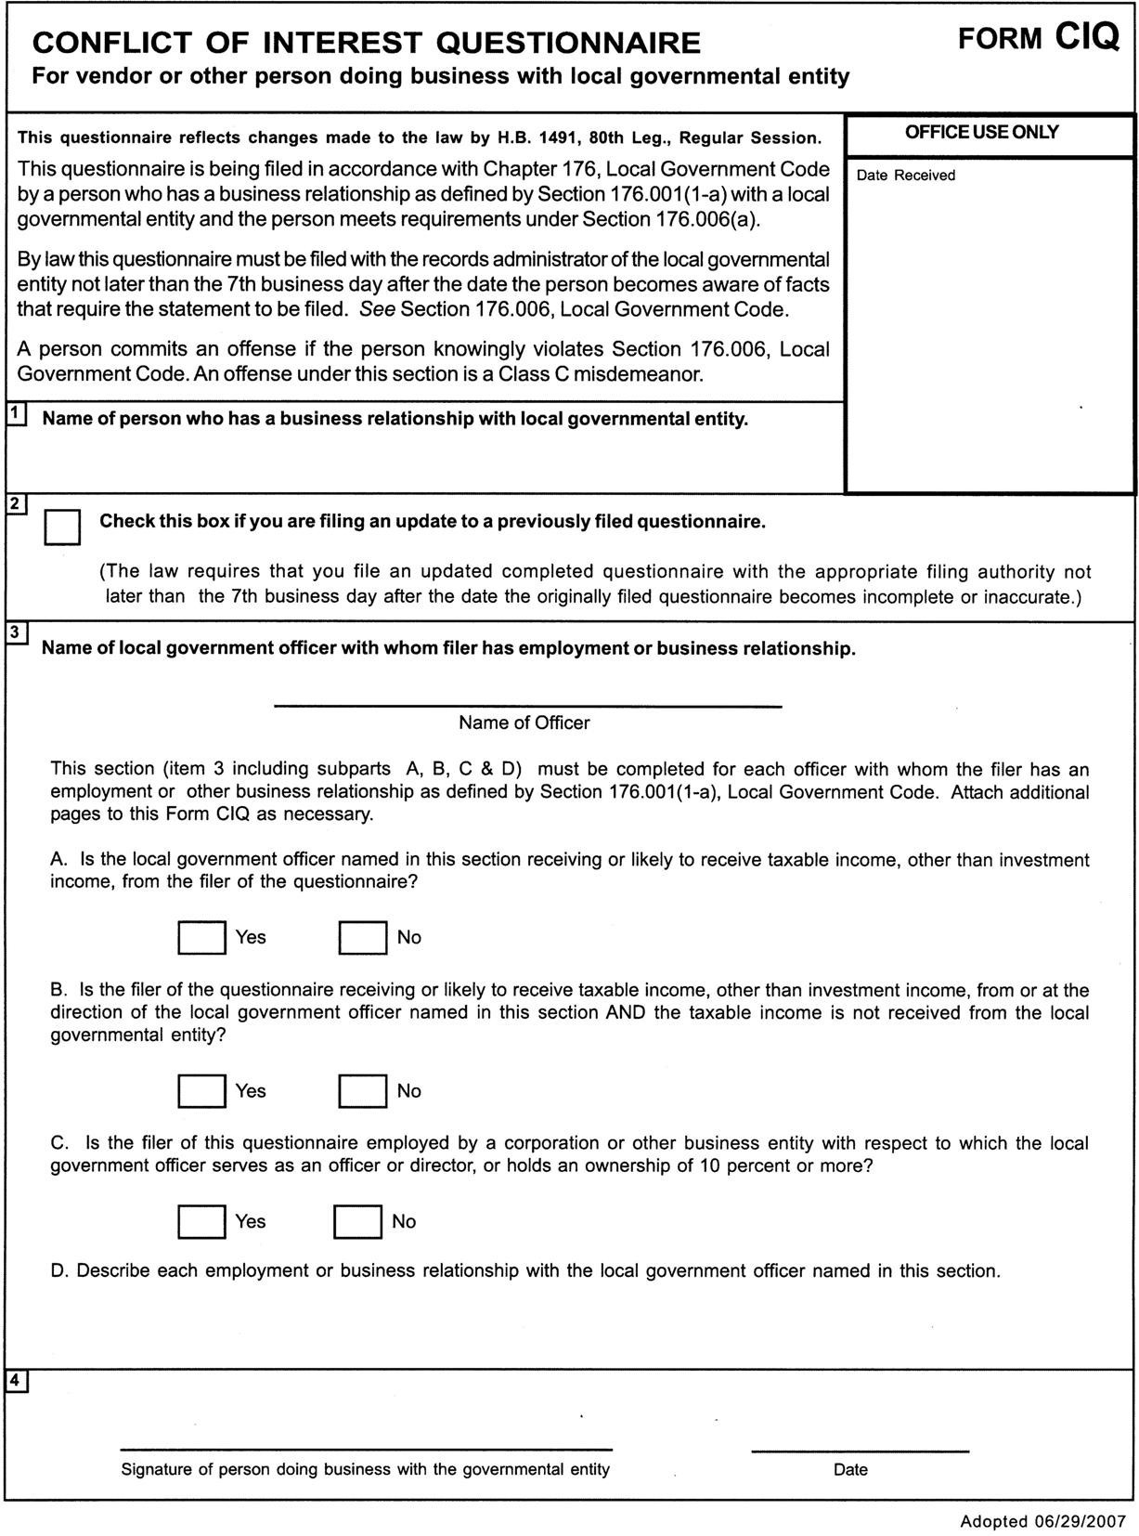

Certificate of Interested Parties (Form 1295):
In 2015, the Texas Legislature adopted House Bill 1295, which added section 2252.908 of the Government Code. The law states that a governmental entity or state agency may not enter into certain contracts with a business entity unless the business entity submits a disclosure of interested parties to the governmental entity or state agency at the time the business entity submits the signed contract to the governmental entity or state agency.

The law applies only to a contract of a governmental entity or state agency that either (1) requires an action or vote by the governing body of the entity or agency before the contract may be signed or (2) has a value of at least$1 million. The disclosure requirement applies to a contract entered into on or after January 1, 2016. The Texas Ethics Commission was required to adopt rules necessary to implement that law, prescribe the disclosure of interested parties form, and post a copy of the form on the commission’s website. The commission adopted the Certificate of Interested Parties form (Form 1295) on October 5, 2015. The commission also adopted new rules (Chapter 46) on November 30, 2015, to implement the law. The commission does not have any additional authority to enforce or interpret House Bill 1295.

Filing Process:
- A disclosure of interested parties form required by section 2252.908 of the Government Code must be filed on an electronic form prescribed by the commission that contains the following:
- The name of the business entity filing the form and the city, state, and country of the business entity’s place of business;
- The name of the governmental entity or state agency that is a party to the contract for which the form is being filed;
- The name of each interested party and the city, state, and country of the place of business of each interested party;
- The identification number used by the governmental entity or state agency to track or identify the contract for which the form is being filed and a short description of the goods or services used by the governmental entity or state agency provided under the contract; and
- An indication of whether each interested party has a controlling interest in the business entity, is an intermediary in the contract for which the disclosure is being filed, or both.
- The certification of filing and the completed disclosure of interested parties form generated by the commission’s electronic filing application must be printed, signed by an authorized agent of the contracting business entity, and submitted to the governmental entity or state agency that is the party to the contract for which the form is being filed
- A governmental entity or state agency that receives a completed disclosure of interested parties form and certification of filing shall notify the commission, in an electronic format prescribed by the commission, of the receipt of those documents not

later than the 30th day after the date the contract for which the form was filed binds all parties to the contract.
- The commission shall make each disclosure of interested parties form filed with the commission undersection 2252.908(f) of the Government Code available to the public on the commission’s Internet website not later than the seventh business day after the date the commission receives the notice required under subsection (c) of this section.

CERTIFICATE OF INTERESTED PARTIES FORM 1295
Complete Nos. 1 - 4 and 6 if there are interested parties. Complete Nos. 1, 2, 3, 5, and 6 if there are no interested parties. |  |  |  | OFFICE USE ONLY
1 Name of business entity filing form, and the city, state and country of the business entity's place of business.
2 Name of governmental entity or state agency that is a party to the contract for
which the form is being filed.
3 Provide the identification number used by the governmental entity or state agency to track or identify the contract, and provide a description of the services, goods, or other property to be provided under the contract.
4 | Name of Interested Party | City, State, Country (place of business) | Nature of Interest (check applicable)
 |  |  | Controlling |  | Intermediary
5 | Check only if there is NO Interested Party.
6 UNSWORN DECLARATION
My name is , and my date of birth is .

My address is , , , , . (street) (city) (state) (zip code) (country)
I declare under penalty of perjury that the foregoing is true and correct.

Executed in County, State of , on the day of , 20 .
(month) (year)

Signature of authorized agent of contracting business entity (Declarant)
ADD ADDITIONAL PAGES AS NECESSARY
Form provided by Texas Ethics Commission www.ethics.state.tx.us Revised 12/22/2017
Must file online at www.ethics.state.tx.us/File

SCOPE OF WORK “EXHIBIT A”

Professional Landscape Care and Maintenance

The City of Bastrop Water and Wastewater Department is accepting proposals for Lawn and Landscaping maintenance services to begin on November 1, 2025 and continue through September 30, 2026.

Please include the following in the monthly cost of your proposal:

- Mowing
Approximate areas indicated on the attached map excerpt within the red bounds. Accessible areas on the EXTERIOR of the perimeter fence will need to have a minimum mow path of 5’ in width, where feasible.
Basis: MONTHLY, WITH EXCEPTION TO THE WEST WWTF WHICH SHALL BE PERFORMED BIWEEKLY.

- Weed eating/Trimming
Weed eating around trees, landscape beds, sidewalks and curbs. Shrubs will be trimmed on to keep a clean and attractive appearance.
Basis: MONTHLY, WITH EXCEPTION TO THE WEST WWTF WHICH SHALL BE PERFORMED BIWEEKLY.

- Tree Maintenance
Trees need to be pruned and maintained to keep a clean and attractive appearance.
Basis: “as needed”

- Cleanup
Removal of trash prior to mowing each time. All clippings, grass and thatch will be removed for all areas by blowing off or bagging.
Basis: MONTHLY

- Plant and bed care
Landscaped beds shall be edged and will be edged prior to mulching.
Basis: “as needed”

- Weeding
Will be performed as needed to keep any landscape beds FREE OF WEEDS at all times either by hand pulling or herbicide spraying. If spraying, COPIES OF VALID LICENSE THROUGH TDA AND VALID INSURANCE WILL BE NEEDED.
Basis: “as needed”
- Insurance
Must provide Certificate of Coverage for LIABILITY AND WORKMAN’S COMPENSATION INSURANCE and update when expired. City of Bastrop must be named as an additional insured.

Facility Names and Locations

FACILITY | LOCATION COORDINATES | TOTAL MONTHLY COST FOR LOCATION (TO BE COMPLETED BY BIDDER)
North Pecan Lift Station | 30.133469, -97.318049 | $____________________
Main Street Lift Station | 30.125365, -97.320168 | $____________________
Pecan Park I Lift Station | 30.099983, -97.324742 | $____________________
Mauna Loa Lift Station | 30.101270, -97.292971 | $____________________
River Lift Station | 30.103565, -97.320810 | $____________________
Home Depot Lift Station | 30.107701, -97.353933 | $____________________
East Wastewater Treatment Facility | 30.102440, -97.318381 | $____________________
West Wastewater Treatment Facility | 30.090443, -97.355368 | $____________________
Willow Water Treatment Plant | 30.115779, -97.325584 | $____________________
Bob Bryant Water Treatment Plant | 30.120978, -97.342641 | $____________________
Wells H & I | 30.121190, -97.340887 | $____________________
Loop 150 Tank Yard | 30.109826, -97.294818 | $____________________
FM-20 Tank Yard | 30.107884, -97.374005 | $____________________
TOTAL MONTHLY COST FOR ALL LOCATIONS |  | $____________________

NORTH PECAN LIFT STATION

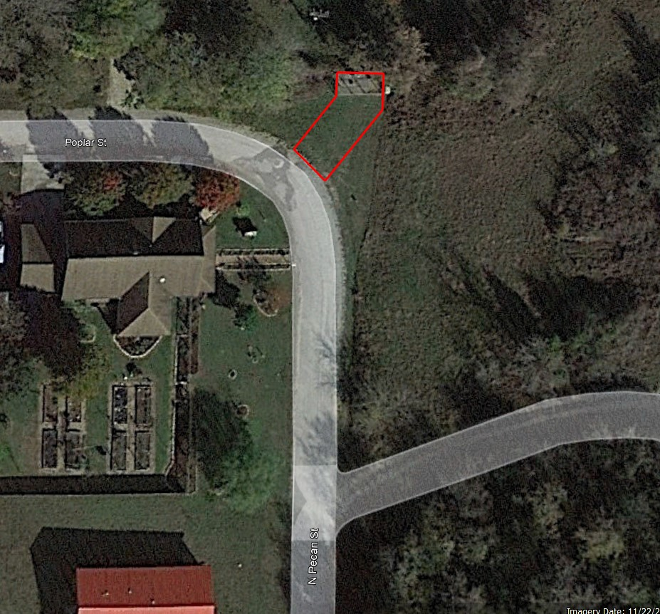

MAIN STREET LIFT STATION

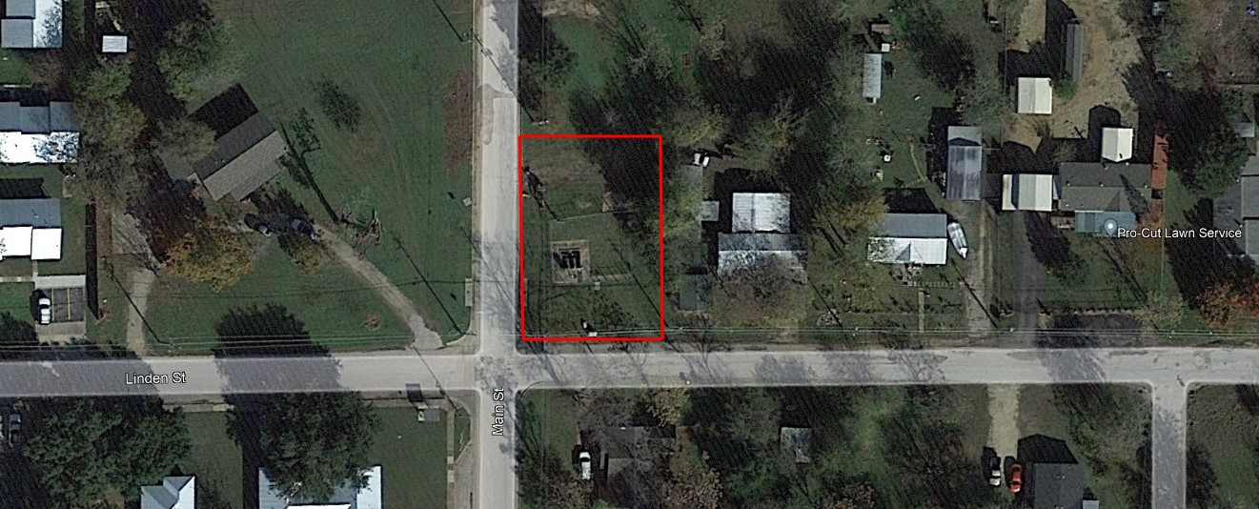

PECAN PARK I LIFT STATION

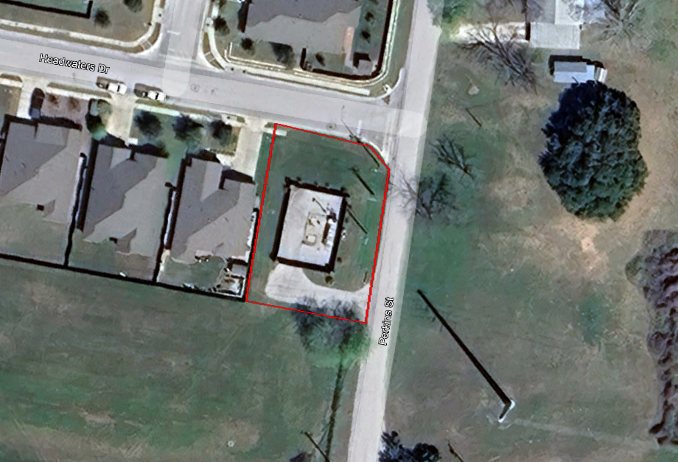

MAUNA LOA LIFT STATION

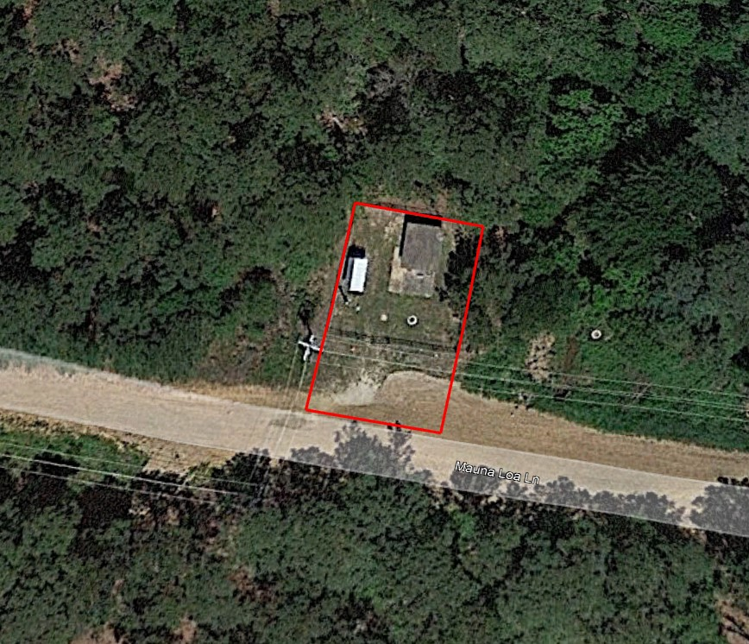

RIVER LIFT STATION

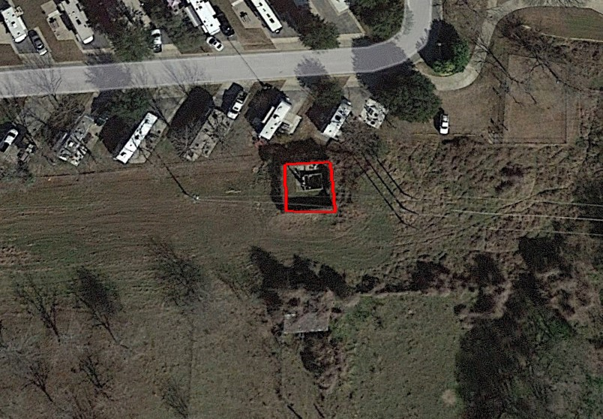

HOME DEPOT LIFT STATION

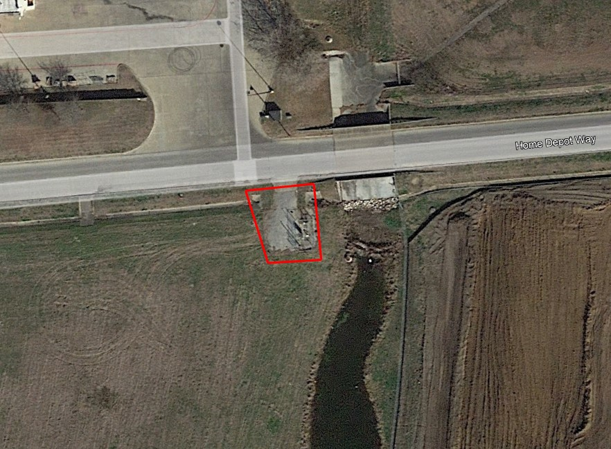

EAST WASTEWATER TREATMENT FACILITY

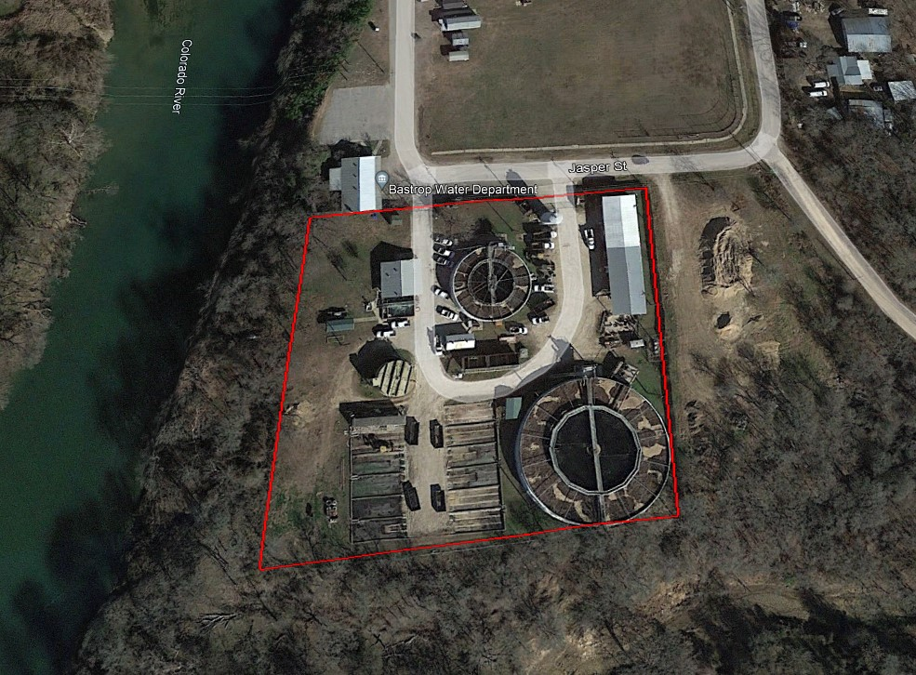

WEST WASTEWATER TREATMENT FACILITY

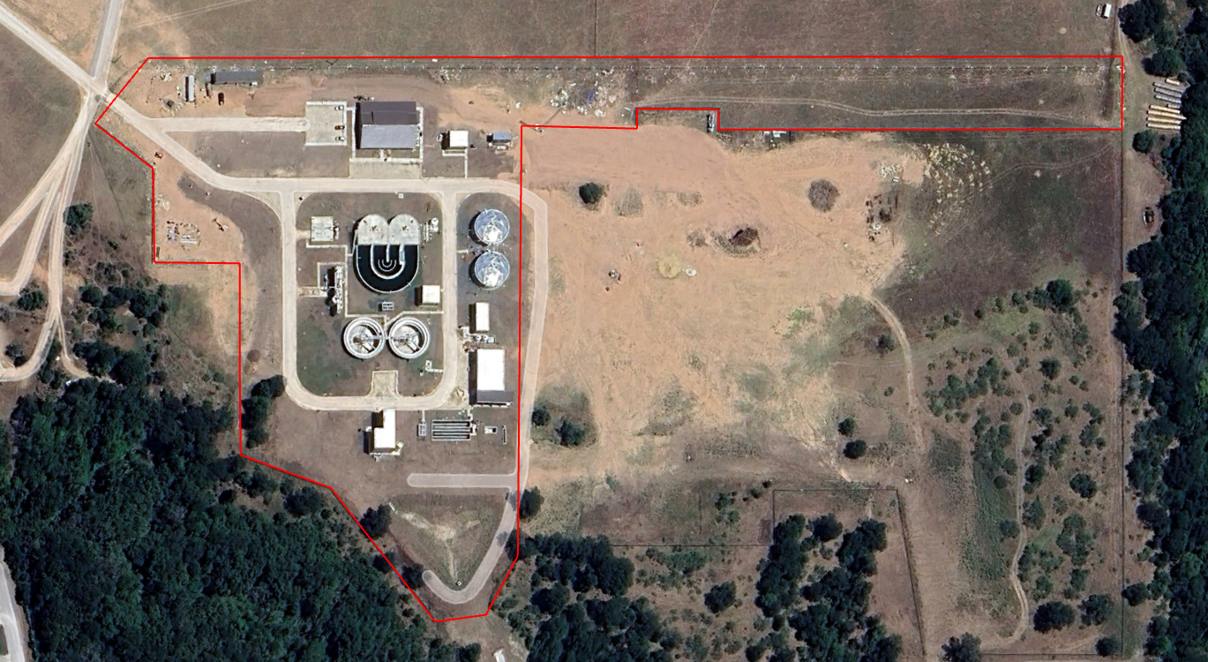

WILLOW WATER TREATMENT PLANT

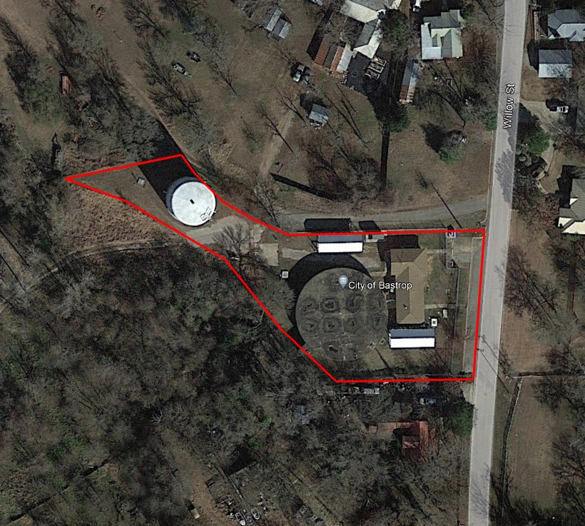

BOB BRYANT WATER TREATMENT PLANT

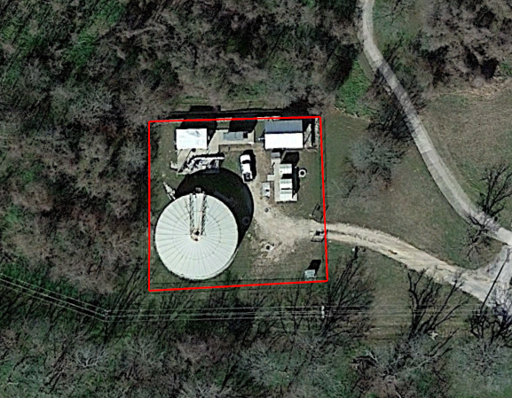

WELLS H & I

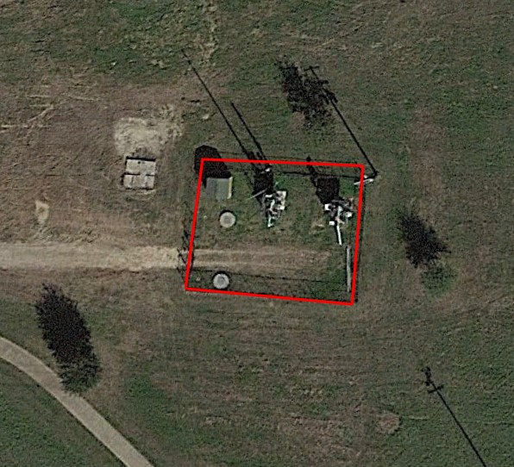

LOOP 150 TANK YARD

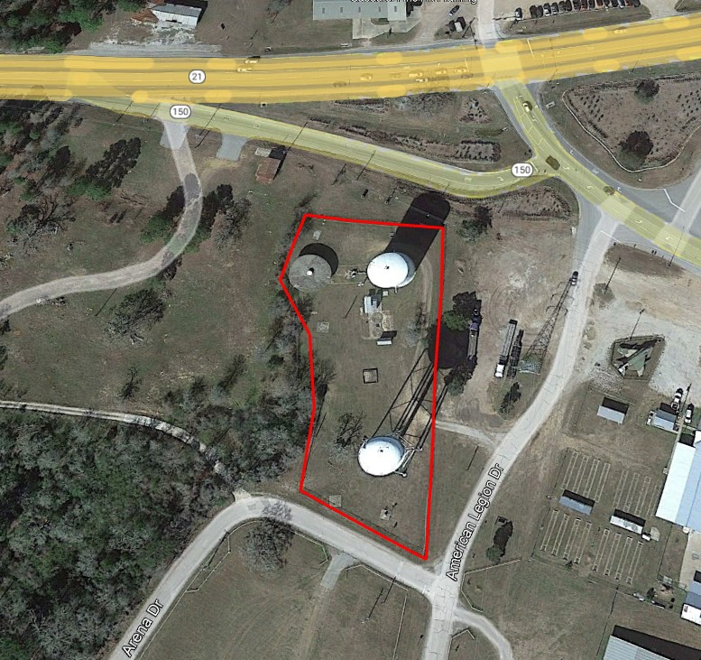

FM-20 TANK YARD

